# AcqManager

# Menu Devices Guide (*Hardware setup*)

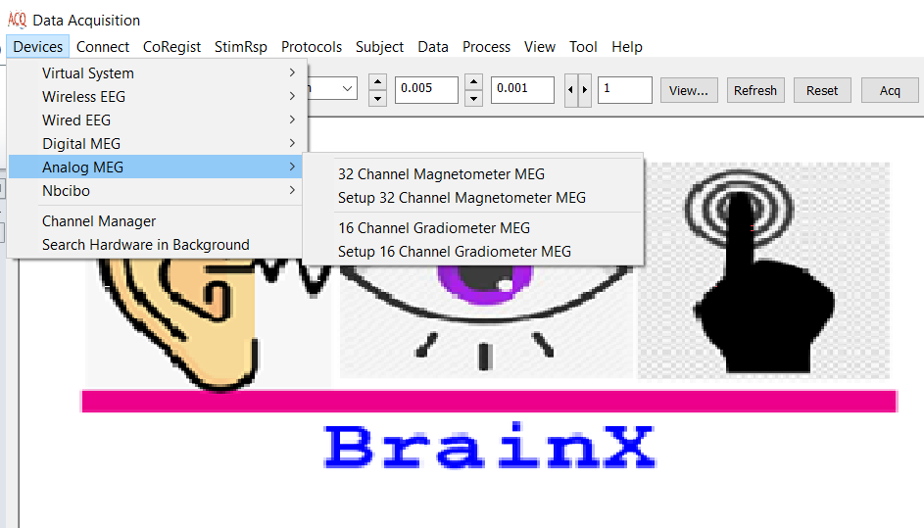

# DISCLAIMER

We have used reasonable effort to include accurate and up-to-date information in this manual; it does not, however, make any warranties, conditions or representations as to its accuracy or completeness. We assume no liability or responsibility for any errors or omissions in the content of this manual. Your use of this manual is at your own risk. Under no circumstances and under no legal theory shall the authors be liable for any indirect, direct, special, incidental, punitive, exemplary, aggravated or consequential damages arising from your use of this manual.

Features and specifications of this software program are subject to change without notice. This manual contains information and images about AcqManager, its user interface, GUI and its other signal processing algorithms, publications that are protected by copyright.

All rights reserved. This publication may be reproduced, stored in a retrieval system, or transmitted, in any form or by any means, electronic, mechanical, photocopying, recording, or otherwise, with prior permission by the authors.

*Sending Your Comments and Critiques:* We’d like to hear from you. Your comments and suggestions for improving this document are welcome and appreciated. Please e-mail your feedback to support@mecurer.com

Thank you.

Contents

AcqManager 1

Menu Devices Guide (*Hardware setup*) 1

DISCLAIMER 2

*Warnings and Cautions* 5

Preface 6

Using Menu Devices 7

Selecting Devices (Data Acquisition Connection and Digitization Cards) 7

Supported Devices (tested systems) 8

Virtual System 8

21 Channel Virtual MEG System: 8

21 Channel Virtual EEG System: 9

Wireless EEG 10

BLE 11 EEG System 11

BLE 19 EEG System 11

WiFi 11 EEG System 11

WiFi 19 EEG System 11

Wire EEG 12

EEG 32 (Unipolar): 14

EEG 16 (Bipolar) 14

Digital MEG 14

What’s in the box of QuSpin QZFM (OPM Sensor)? 15

Hardware Setup 15

Software Setup: Current Release 17

Software Setup: Initial Release 20

Operating the Sensors 20

At this point the sensors are ready for measurement. 21

Additional Controls 21

Data Save 22

Data Plots 23

Analog MEG 23

32- Channel Magnetometer MEG: 24

16-Channel Gradiometer MEG: 24

Channel Manager (Setup) 24

Search Hardware 25

Index 25

# *Warnings and Cautions*

This software supports data acquisition for magnetoencephalography (MEG), electroencephalography (EEG) and other bioelectromagnetic signals. Though MEG and EEG waveforms appear similar, they have different unit in amplitude. If the MEG and EEG data recorded simultaneously, their time unit or temporal resolution is typically the same.

Modern MEG/EEG systems typically have MEG/EEG sensor/electrode channels as well as other channels. For example, trigger channel, head-localization channels and additional ADC (analog-to-digital) channels. To avoid problems, please pay attention to the channel names and the amplitude value/unit. Their values may be of different orders of magnitude. Unexpected results may occur if their values are mixed in measurements.

When performing waveform analysis, regardless of whether MEG or EEG or both are displayed, ensure that the data are appropriately filtered with DC-offset/linear-trend removal. If the waveforms had very large amplitude (e.g. > 3 pt), it is recommended that you identify possible noise.

There are a set of source localization algorithms in the program. Each source localization algorithm has been designed and tested for specific reasons. To ensure the quality and visibility, all source localization algorithms will generate a volumetric source image, which can be considered as an image with millions of “dipoles” or multi-value-voxel, which is significantly different from the conventional magnetic source imaging (MSI) or equivalent current dipoles.

Head movement during MEG recordings may affect the accuracy of source imaging. If subjects move too much during MEG recordings, the MEG results are more than likely poor.

The accuracy of the structural images (MRI/CT) may also affect the MEG results if the conventional magnetic source imaging (MSI) is used. If MRI/CT is distorted, the combination of MEG/MRI/CT will be low-quality. In addition, multiple local sphere, head model or other structural constrained source localization my internally use the MRI/CT images. Any analysis based on those distorted images may yield unexpected or poor results.

The following warnings and cautions appear in this guide. Please ensure you are aware of all the operations and interpretations.

# Preface

The Main Frame is one of the core windows of AcqManager software. It is used as the primary tool to view MEG, EEG, MCG, ECG, triggers and other data, mark and classify the data, and identify results of interest for academic or clinical purposes. Importantly, the Main Frame provides graphic user interface (GUI) for access other function. In other words, it is also often used to launch other windows such as source localization.

This guide describes the operation of the AcqManager application for MEG/EEG/MCG/ECG. Though there are many functions related to MRI/CT, analyses of MRI/CT are not the focuses of this guide.

*Determining the Software Version*

In the Main Frame: select Help -> About.

The About Dialog will show the version of the software.

*Intended Audience*

This guide is intended for anyone needing to record and view (online) data with an appropriate hardware system. It assumes the technologist/operator is familiar with standard MEG/EEG/MCG/ECG procedures and with the Windows operating systems.

*Document Structure*

Documents are generally provided in both Microsoft Word® format and Adobe® Acrobat® PDF (Portable Document Format). All editions are distributed on Flash Driver, CD or websites with the related software, and include bookmarks and hyperlinks to assist navigating the document. Please feel free to send your critiques, corrections, suggestions and comments to support@mecurer.com.

*Conventions*

Numeric: Numeric values are generally presented in decimal but in special circumstances may also be expressed in hexadecimal or binary. Hexadecimal values are shown with a prefix of 0x, in the form 0x3D. Binary values are shown with a prefix of 0b, in the form 0b00111101. Otherwise, values are presumed decimal.

Units: Units of measure are given in metric. Where measure is provided in imperial units, they are typically shown in parenthesis after the metric units. Biomagnetic signal strength is given in Teslas (T), the SI unit of flux density (or field intensity) for magnetic fields, also known as the magnetic induction. Typical signal strengths in biomagnetic measurements are in the order of pT (picoteslas = 10-12) or fT (femtoteslas = 10-15). Electrical signal strength is given in volts (V). Bioelectrical activity is typically quite small, measured in microvolts (mV).

# Using Menu Devices

This menu provides access to a set of devices that are supported by AcqManager.

# Selecting Devices (Data Acquisition Connection and Digitization Cards)

The software supports an increasing list of devices (data acquisition card) or hardware or systems. To setup data acquisition protocol, it is necessary to select the devices before setting other parameters.

Figure 1. AcqManager Main Frame and Waveform Viewer (during MEG recordings).

(1) Select Menu “Devices”-> Select Type of devices (“Analog MEG”)->Sub-model (“32 Channel Magnetometer MEG”).

For example:” Devices->Wireless EEG ->WiFi 11 Channel EEG System” will select Wi-Fi EEG system for data acquisition.

(2) Once the Device is selected, the number of channels and the sampling rate will be determined or defined consequently.

(3) If the device was just installed or modified, it may be necessary to setup the device (e.g., check the connection) . It is recommended for first time usage.

# Supported Devices (Tested systems)

AcqManager supports a set of bioelectromagnetic systems. Biomagnetic (e.g. MEG) systems are typically more complicated than bioelectric (EEG) systems. Following systems are commonly used in research and clinical environments. For training or practice, this software also supports virtual systems, which simulate brain activity.

# Virtual System

This category does not need to install any devices or hardware. The computer will simulate a virtual MEG or EEG system for data acquisition or recordings. The recorded data can be viewed, edited and analyzed. This function is preliminarily designed for training, education, research and development of signal process, visualization and many other purposes.

Virtual MEG and EEG systems in AcqManager are written in C++ and implements streamlined standard methods to solve hyperbolic partial differential equations such as the damped 2D wave equation; time stepping methods to solve ordinary differential equations; and procedures for delay differential equations. Careful numerical analysis has resulted in a suite of methods that is fast, accurate, and robust. Thus the present work obviates the need for users to become familiar with all these techniques and underlying theory, program them, and then debug several thousand lines of code. The code has been tailored to use these state equations to solve an unlimited number of user-defined continuum neural field models. Users can use GUI to input the signals that suitable for various purposes. The output can be visualized and analyze in the main window. AcqManager can be easily integrated into existing workflows and analyses so as to just start some methodological works (e.g., test a time-frequency or network analysis methods. The results can natively be read by MEG Processors or EEG Studio. In addition, the simulated MEG/EEG data can be exported to text file, which can be analyzed by any other methods, such as many toolboxes based on Matlab functions.

## 21 Channel Virtual MEG System:

This device is a virtual MEG system, with 21 channels of magnetic sensors based on optically pumped magnetometer (OPM). The signal in this system can be designed or simulated.

Setup Simulation Signal: The signals in the virtual MEG, EEG or any biomagnetic or bioelectric systems are simulated or computed. Users can change the settings of the signals to generate a variety of signals for a specific aim.

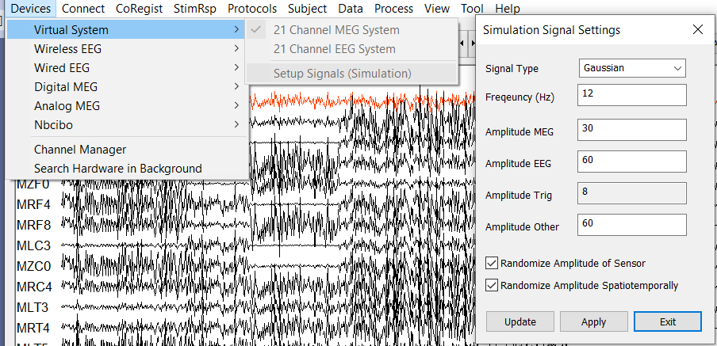

Figure 2. Virtual MEG and EEG systems.

## 21 Channel Virtual EEG System:

This device is a virtual EEG system, with 21 channels of electrodes connected wirelessly to the data acquisition card.

Setup Simulation Signal: similar to the setup in virtual MEG systems, the signals in the virtual MEG, EEG or any biomagnetic or bioelectric systems are simulated or computed. Users can change the settings of the signals to generate a variety of signals for a specific aim. The parameters can be edited include signals type, frequency, amplitude, simulated variation among sensor and time.

Signal type: several types of signals can be simulated. The types of signals include sine, cosine, square, Gaussian and white noise. The signals from the brain similar to the Gaussian signals.

The amplitude can be tailored for visualization and data analysis in a variety of unique conditions.

# C:\Users\jingx\AppData\Local\Microsoft\Windows\INetCache\Content.Word\wireless EEG.JPG

Figure 3. Wireless EEG systems.

# Wireless EEG

Wireless EEG is different from the conventional EEG, which is connected from head to data acquisition card to electronics to the computer. Wireless EEG simplified the connection from the card/electronics to the computer; consequently, provide a freedom for patients/clinicians/users. The devices provide anyone with a computer, the tools necessary to sample the electrical activity of the human body. The biosensing systems can be used to sample electrical brain activity (EEG), muscle activity (EMG), heart rate (ECG), body movement, and much more.

AcqManager provide the optimal, versatile and affordable graphic user interface to record EEG signals with Bluetooth (BLE) and/or Wifi (Wi-Fi).

## BLE 11 EEG Systems

This device is an EEG system, with 8 channels of electrodes connected and 3 channels of motion detectors to computer with Bluetooth (a USB Bluetooth to Com port).

## BLE 19 EEG Systems

This device is an EEG system, with 16 channels of electrodes and 3 channels of motion detectors connected to computer with Bluetooth (a USB Bluetooth to Com port).

## WiFi 11 EEG System

This device is an EEG system, with 8 channels of electrodes and 3 channels of motion detectors connected wirelessly to computer with Wi-Fi.

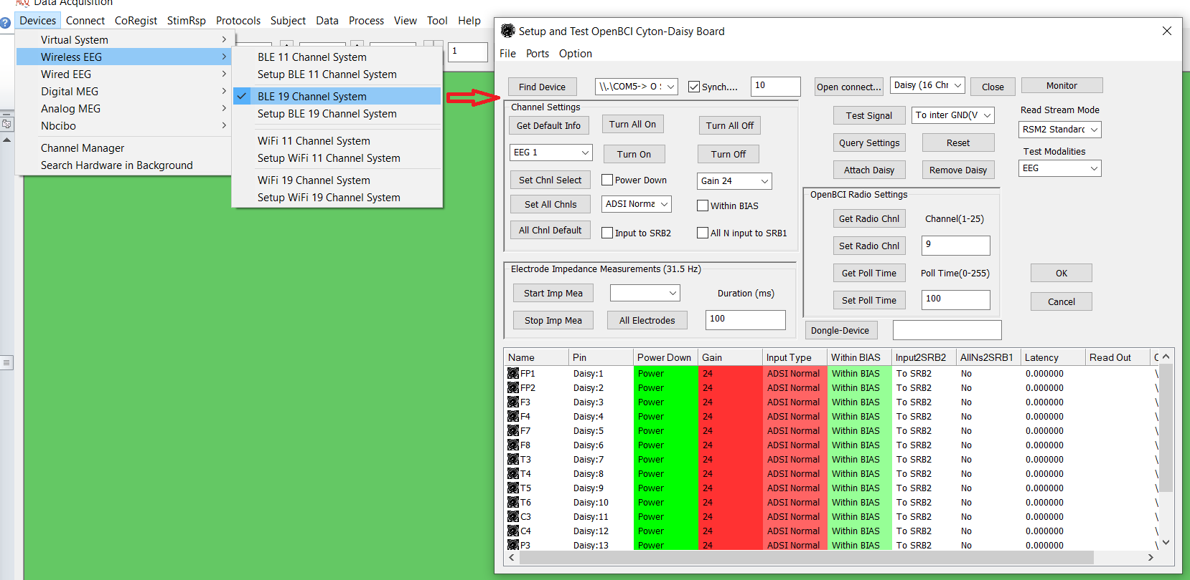Figure 4. GUI for Setup the parameters to wirelessly record bioelectric signals (such as EEG, ECG) with Bluetooth (through COM).

## WiFi 19 EEG System

this device is an EEG system, with 16 channels of electrodes and 3 channels of motion detectors connected wirelessly to computer with Wi-Fi.

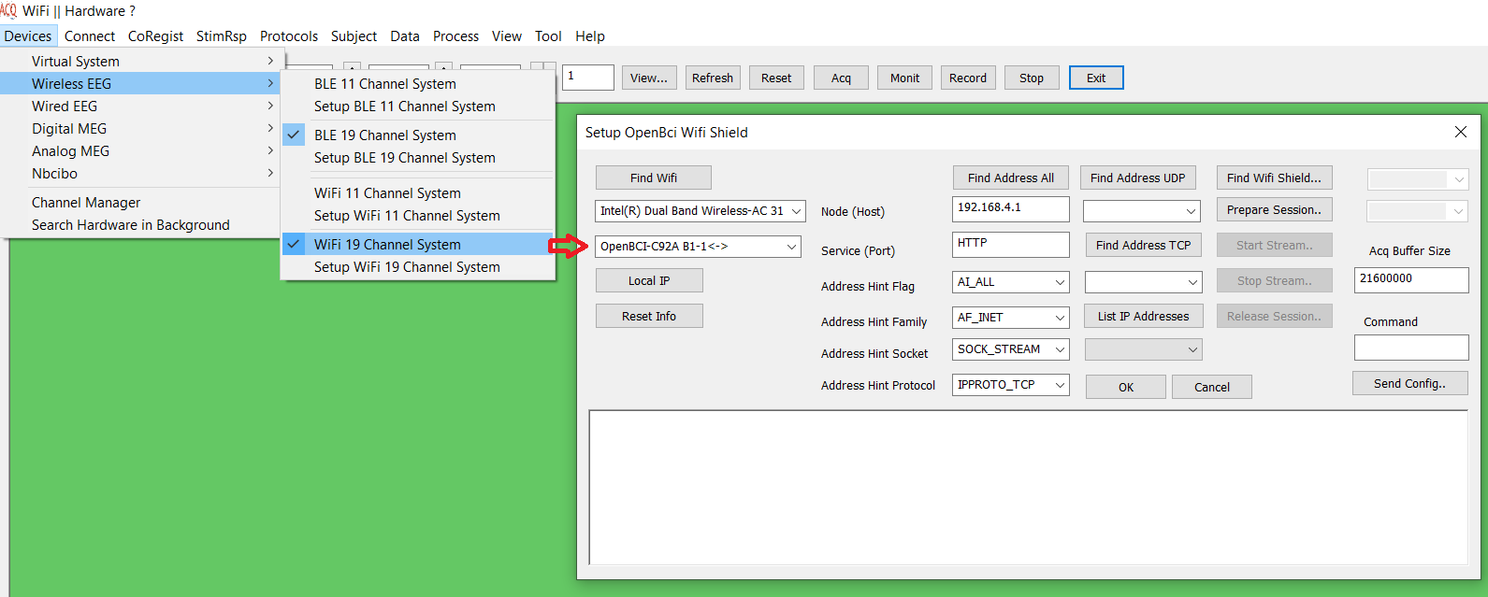Figure 4. GUI for Setup the parameters for wirelessly recording bioelectric signals (such as EEG, ECG) with Wi-Fi.

# Wire EEG

AcqManager supports National Instruments (NI) card for EEG data acquisition. There are different types of EEG systems for a variety of purposes. AcqManager supports an NI DAQ board to develop a system that acquires and analyzes EEG signals. Users can connect the signals from an existing preamplifier to the DAQ board inputs. The board processes and analyzes the recorded signals. User can extract parts of the signal (epochs) to filter it and perform spectral analysis by calculating average fast Fourier transform (FFT). Because an EEG signal is not a steady signal, users must use analysis methods that offer information about the signal in the time-scale domain. Therefore, AcqManager support online filter and offline data analyses. Offline analyses can analyze the continuous, discrete wavelet transformation. For signal calibration, the user may select a few option from the main menu and set the duration and number of channels. The calibration data remains in the system’s memory until it performs the next calibration. 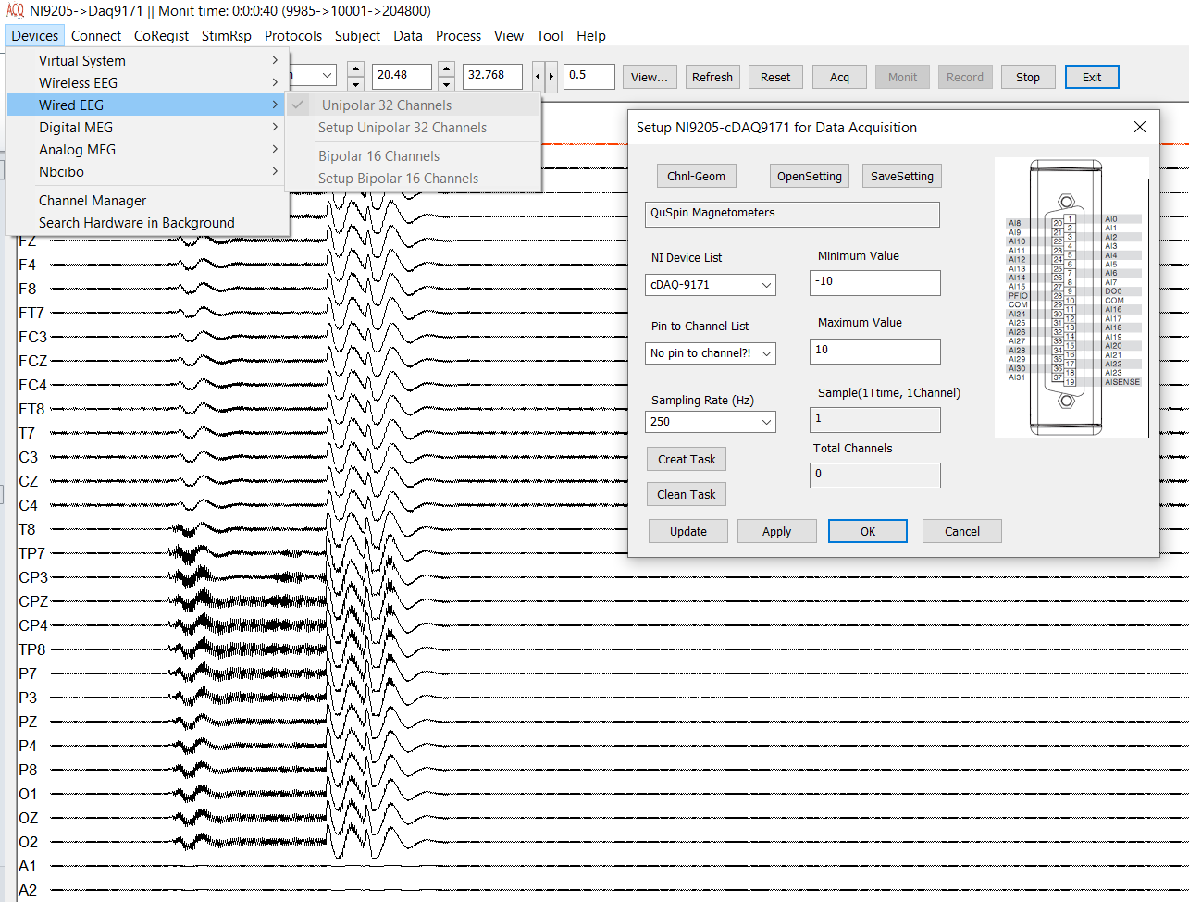

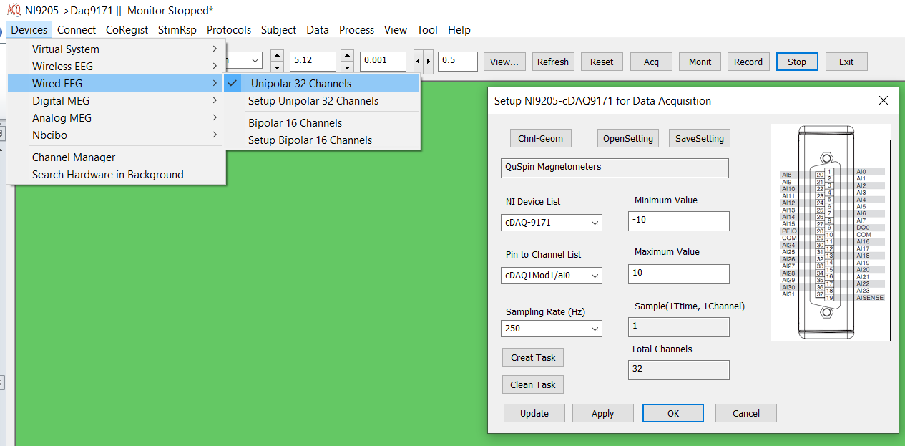

## EEG 32 (Unipolar):

The system supports 32 channels connected directly to the NI card, which are physically connected to the computer. The electrodes are physically connected to each pin. A common ground channel is typically necessary.

## EEG 16 (Bipolar)

The system supports 16 channels connected directly to the NI card, which are physically connected to the computer. Two electrode pair are physically connected to pairs of pins for bipolar recordings.

# Digital MEG

AcqManager supports a variety of sensors. AcqManager for QuSpin sensors supports QZFM Sensor Array. Different from the software provided by QuSpin, AcqManager provides unprecedented flexibility to detect, setup and recorded signals from QZFM sensors.

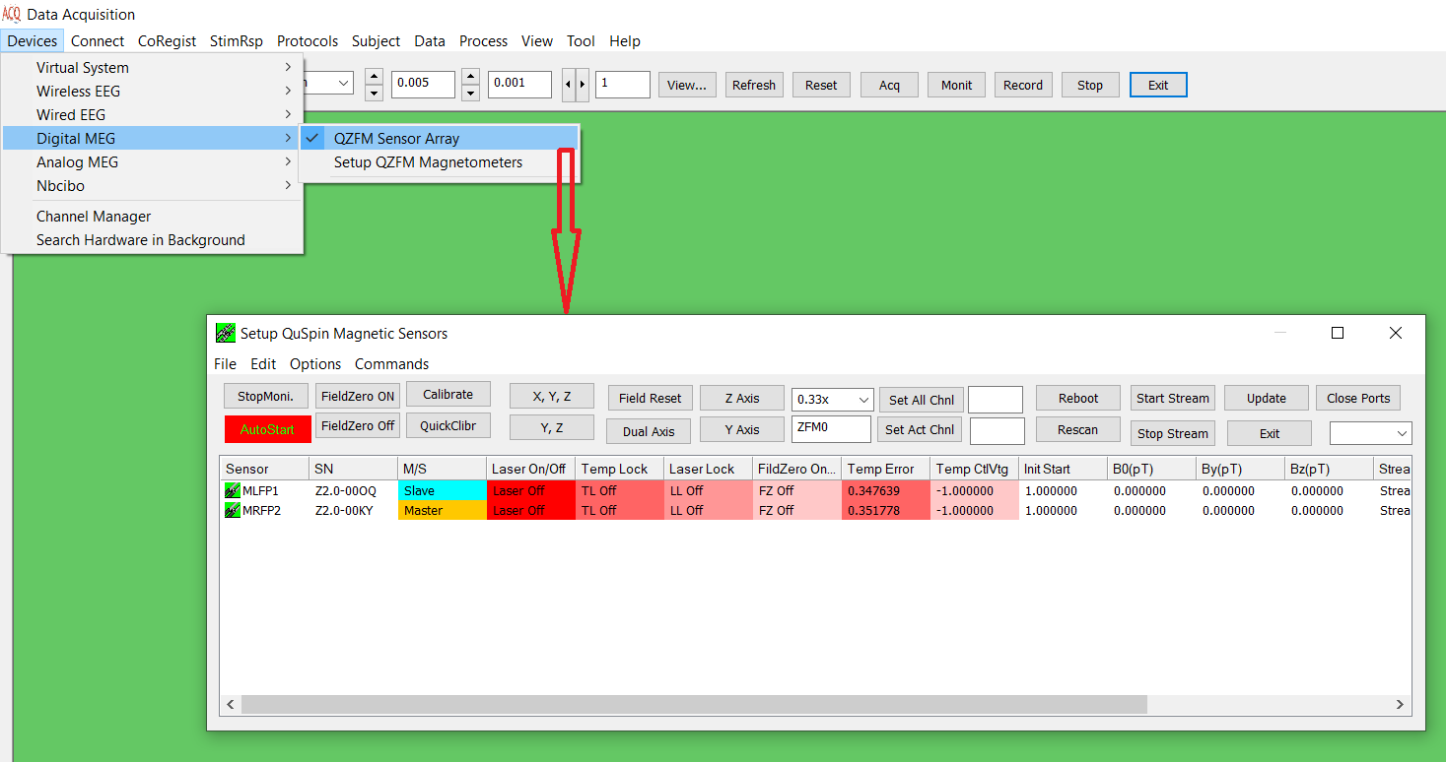Figure 4. GUI for Setup the parameters for recording magnetic signals with QuSpin ZFM sensors.

QuSpin provides the devices to take extreme field sensing from the lab to the real world. QuSpin magnetic sensors are non-cryogenic alternative to superconducting magnetometers, which are based on OPM. The optical magnetometers are extremely sensitive, easy to use. QuSpin sensors have a basic software to setup the sensors.

## What’s in the box of QuSpin QZFM (OPM Sensor)?

The QZFM package includes the following components (Figure 1):

1. Sensor with 20 ft. cable
2. Electronics Module
3. Modulation cable – 3.5 mm to 3.5 mm audio cable (used only for multi-sensor operation)
4. Analog output cable – 2.5 mm audio to 3-way BNC cable
5. USB cable
6. Shorting cap – For sensor cable connector to protect the laser when disconnected from the Electronics Module
7. Power supply – 18V or 19V, 1 unit can power up to 6 sensors (using included cable splitter)

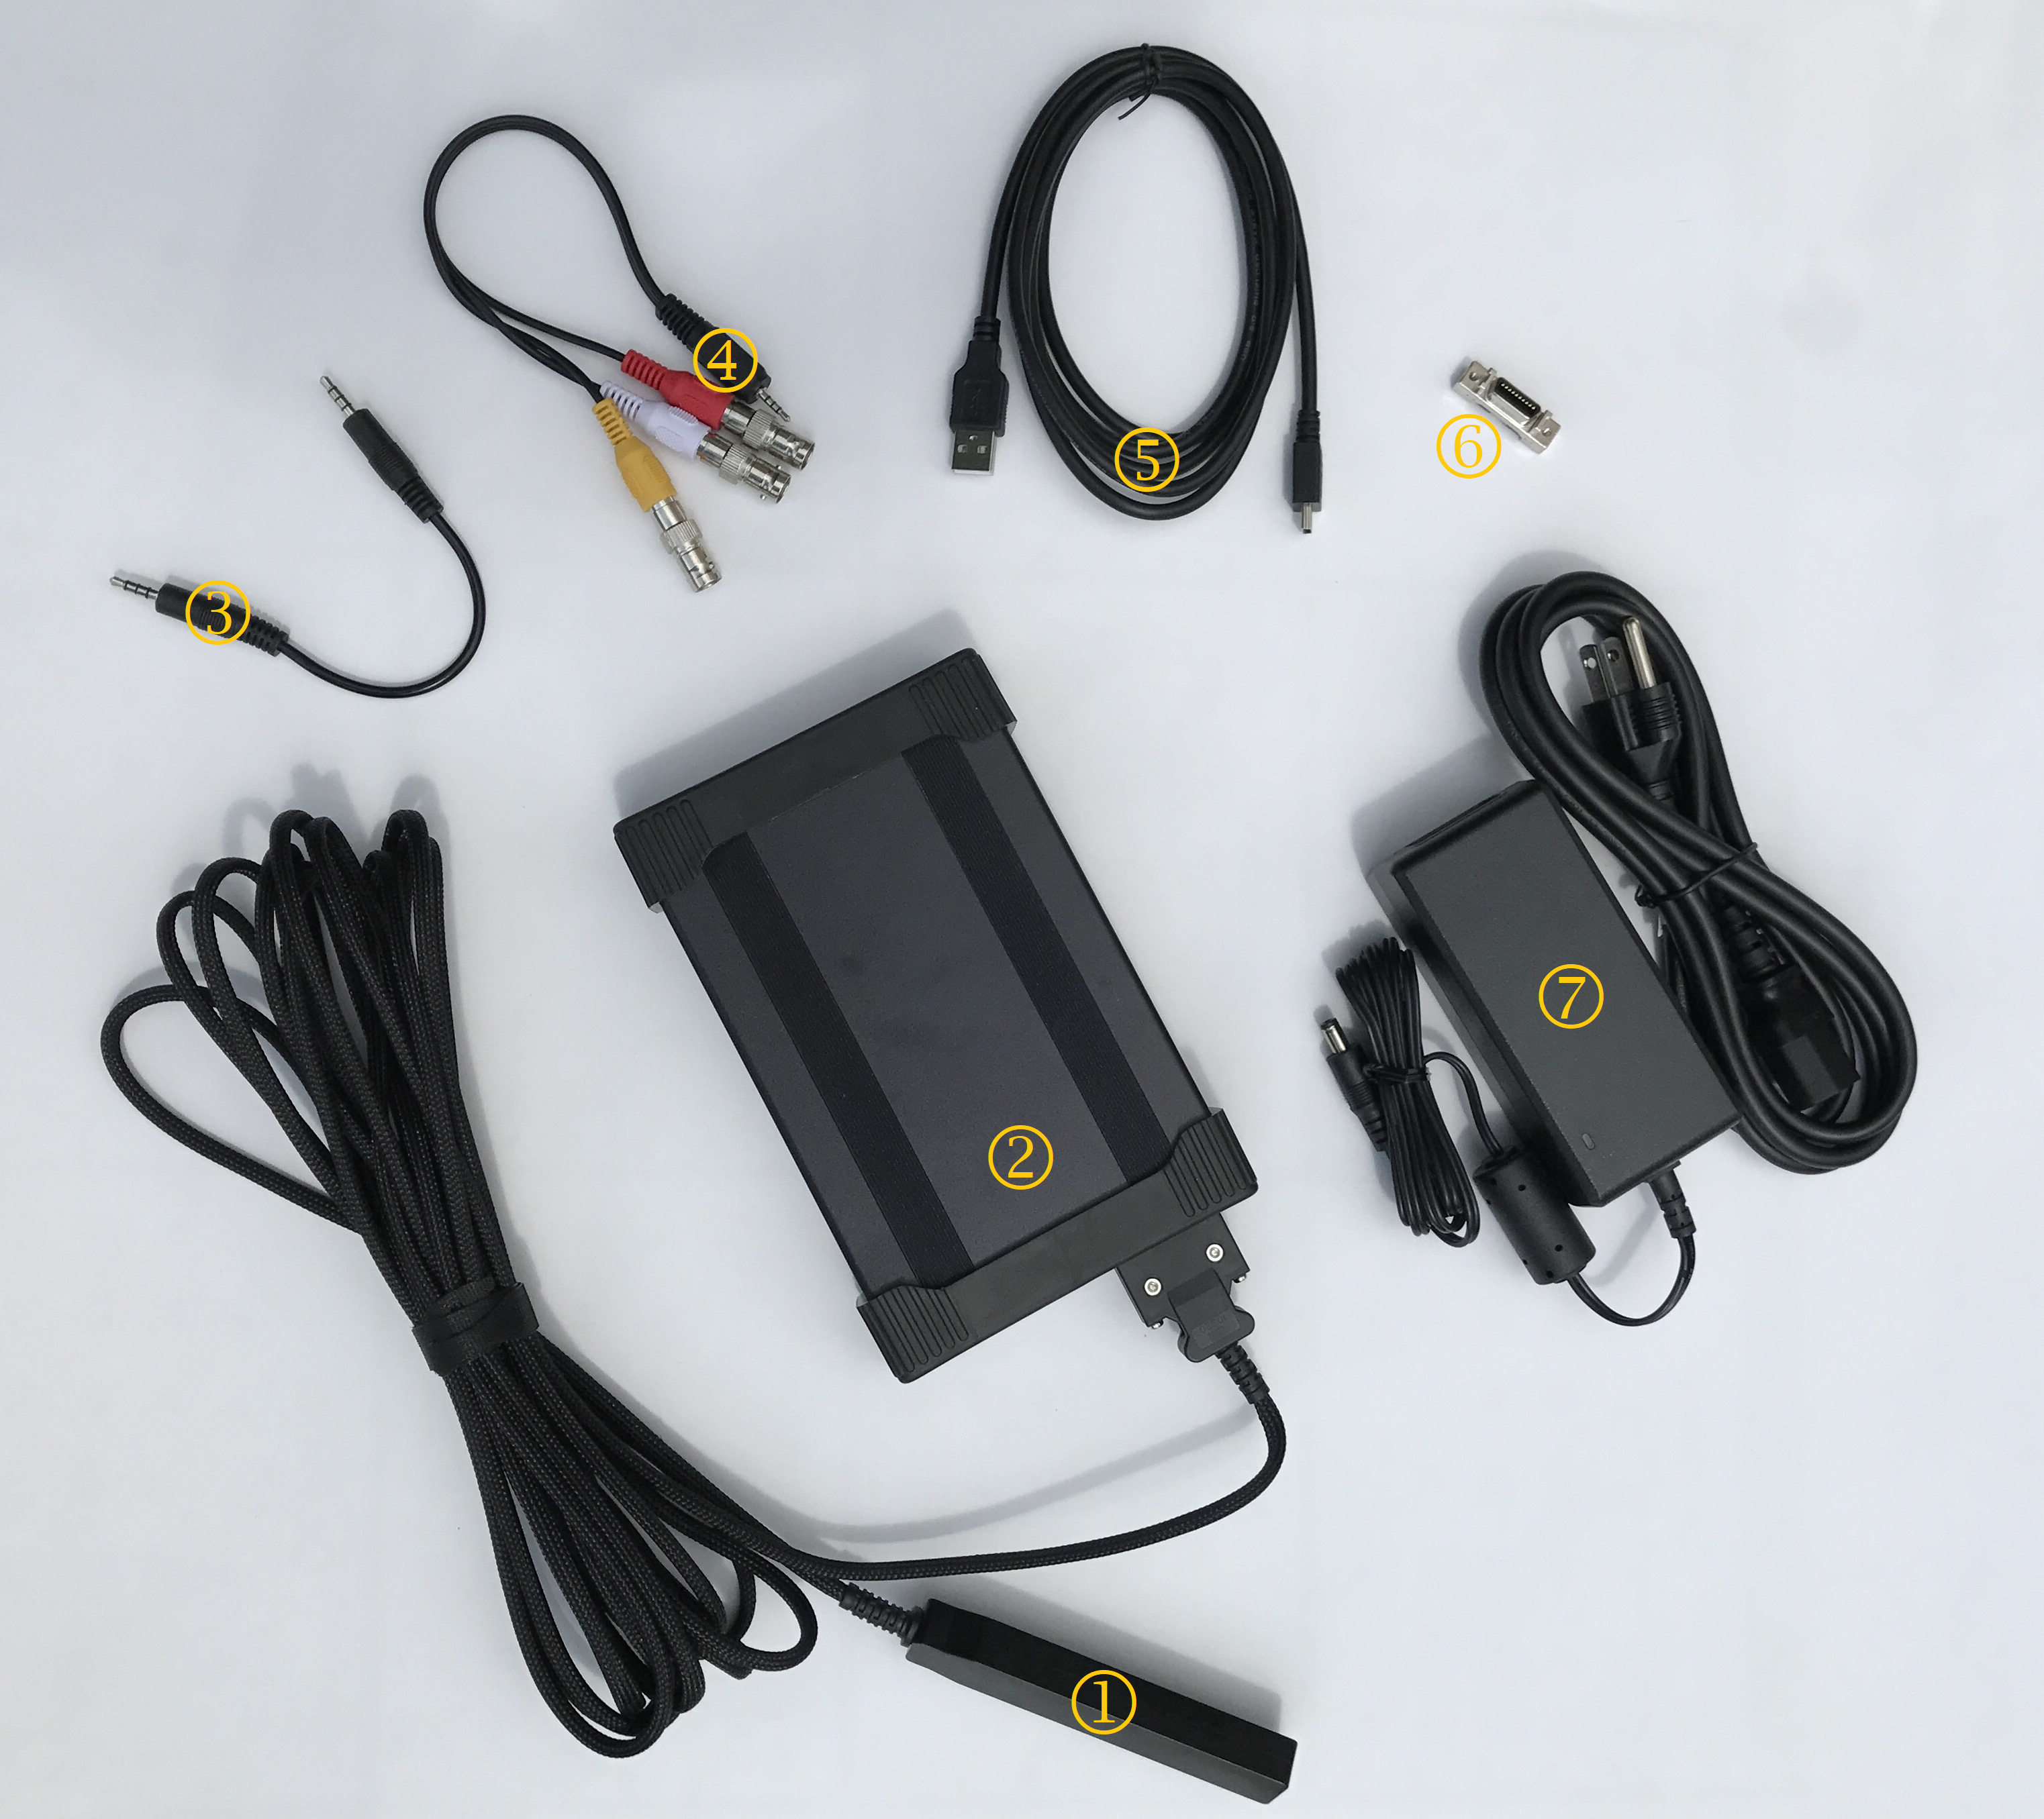

Figure 3A: The QZFM package contains all the necessary hardware needed to run the sensors.

## Hardware Setup

Step 1: Carefully remove the cables and the electronics module with attached sensor from the box.

* **Warning:** **The sensor is highly sensitive to electrostatic discharge (ESD), so please take appropriate precautions (listed below) while disconnecting and reconnecting the sensor.**
* **Note :** In the event the sensor cable has to be disconnected from the electronics module, ensure a well-grounded environment and immediately attach the shorting cap ( in Figure 1) to the connector of the sensor cable and tighten the screws.
* **Note:** With multiple sensors, when reconnecting the sensor cables to the electronics module, check to ensure that the serial number of the sensor matches the serial number (SN) of the electronics module (located on both ends of the sensor as well as on the front and/or side of the electronics module).

[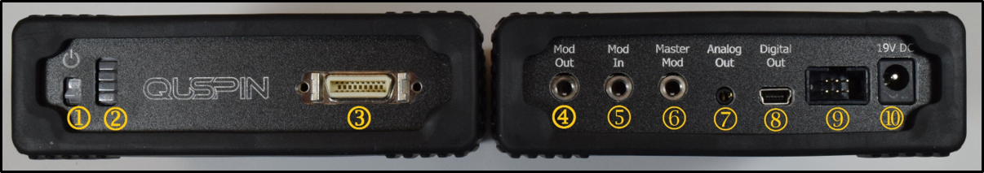](http://quspin.com/wp-content/uploads/2017/03/Figure-2-Front-and-back.png)

Figure 3B A picture of the front (left) and back (right) of the QZFM electronics module showing all the ports.

Step 2: Make sure the power switch (1) on all electronics modules is in the OFF (down) position before connecting the power supply to ’19 V DC’ (10). **Note:** The electronics module can operate with an 18V or 19V power supply.

Step 3: Connect the USB cable between the sensor (‘Digital Out’ port (8) on the electronics module) and the computer. A USB hub can be used for larger number of sensors.

[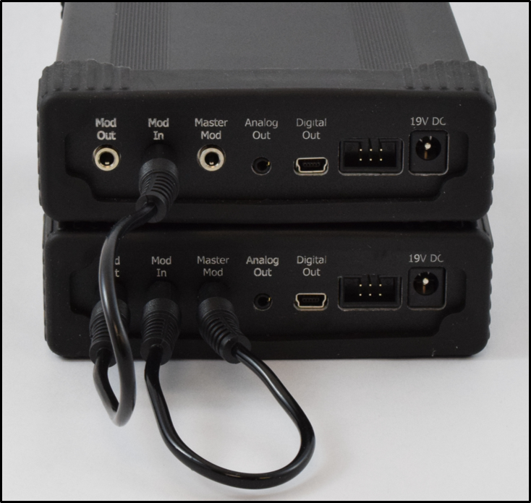](http://quspin.com/wp-content/uploads/2017/03/Picture1.png)

Figure 3b: Connection of modulation cables for Master electronics (bottom) and a slave electronics (top).

Step 4: For multi-channel configurations, the modulation signal must be shared. Connect the modulation cables in the following configuration: For the Master electronics module, connect ‘Master Mod’ (6) to ‘Mod In’ (5) in Figure 3b. Then connect the ‘Mod Out’ (4) from the Master, to the ‘Mod In’ (5) of a Slave electronics module. This can be repeated by connecting the ‘Mod Out’ of that Slave to the ‘Mod In’ of the next Slave until all electronics modules are receiving the Master modulation (See Figure 3).

Step 5: For monitoring or recording the analog output, connect the audio to BNC cable to the ‘Analog Out’ (7) of the electronics module to provide BNC connectivity. The red BNC is for the Z-axis signal and the white BNC is for the Y-axis signal (yellow BNC is not used).

Step 6: : Digital data is sampled asynchronously by each electronics module at 200 Hz (the start time and number of samples recorded will vary slightly for each sensor). Digital data is mainly intended for diagnostic purposes, it is recommended to record analog data with a 16-bit DAQ which allows the data to be recorded synchronously for all sensors. For analog monitoring or recording, the BNC cables can be connected to NI card. Please read the National Instrument (NI) data acquisition for the instruction for the NI card recordings.

## Software Setup: Current Release

QuSpin provide LabVIEW based toolboxes for data monitoring and acquisition. For first time installation it is recommended to download and run the [QZFM UI v3.2 Installer.exe](https://drive.google.com/file/d/1mMONTm9WjXpyGJ54lVdjsEWu--TmGKKP/view?usp=sharing) on a 64-bit PC with Windows 7 or later OS. This includes the installation of LabVIEW VISA drivers and the runtime engine (2014), other drivers, and the QZFM User Interface (UI) application.

The current release requires the [LabVIEW 2015 (or later) 32-bit Runtime engine](https://www.ni.com/en-us/support/downloads/software-products/download.labview.html#306249) which can be downloaded on the National Instruments website at the link provided.

Current UI: [QuSpin ZFM UI V9.0.23](https://drive.google.com/file/d/1v9c1hx4aaigi3RGMblKzsE8FEGPt4OuJ/view?usp=sharing)

Previous Version: [QuSpin ZFM UI V7.6.2](https://drive.google.com/file/d/1m9bF09q8PBuGlQAFd4Fr9_5DTZSg1rtt/view?usp=sharing)

There are video tutorials providing an overview of the QZFM UI functions and operation and applies to both the current and previous versions of the QZFM UI.

Quick demo of basic features of the updated UI:

LED Array:

The LED array at the top displays the last 4 digits of the sensor serial number above 5 LEDs corresponding to active-to-commands status (active sensors will receive commands), LED1 (laser on), LED2 (cell temp locked), LED3 (laser locked), LED4 (field zero complete). The LED array can be clicked on directly to display the sensor corresponding to the column that was clicked on at the top of the array in the “Sensors” tab.

Configuration File:

The location of this configuration file is “C:\QZFM Data\QZFM Configuration File.ini”. The file can be edited to change the order that the sensors are displayed in the UI and other parameters described in this video:

Video Player

The configuration file can be deleted by pressing “Delete Sensor Configuration File” or opened by pressing “Open Sensor Configuration File”. If a previous configuration file exists the connection time will be minimal. If a configuration does not exist, the program will connect to the sensors and create a new configuration file for the next time the UI is opened.

Send Commands ALL ON/OFF:

This button will select and deselect which sensors will have commands sent to them. Make sure ON is displayed next to the name of the sensor to send commands to it, or that OFF is displayed if you do not want to send commands to that sensor.

Select Active Sensors:

The “Select Active Sensors” button allows for convenient selection of sensors to be active for receiving command, printing digital data to the charts, and firmware updates.

Print Buttons:

In the Sensors Tab click the corresponding “PRINT” button to the left of the sensor list to view digital data for that sensor in the Charts Tab. Alternatively you can select a sensor from the “Print Sensor” drop down menu in the Charts Tab, or press the “Print All ON”/”Print All OFF” buttons.

Display From:

This control will move the sensor list so that the Mag# displayed at the top of the list matches the number in the box.

Data Save:

This will record digital data from all sensors. Note: Digital data is printed asynchronously by each electronics module at 200 Hz (the start time and number of samples recorded will vary slightly for each sensor). Digital data is mainly intended for diagnostic purposes, it is recommended to record analog data with a 16-bit DAQ which allows the data to be recorded synchronously for all sensors.

Sensor Info Tab:

This tab allows individual sensors to be selected to read/write sensor specific parameters.

Sensor calibrations are displayed to the right of the corresponding serial number after calibration is run.

Diagnostics Tab:

If a sensor is not working properly it can be selected in the Diagnostics Tab and run through an automatic diagnostics routine. After the diagnostics routine is complete, a screenshot of the page and explanation of the problem can be sent to jo@quspin.com or info@quspin.com for further assistance.

Diagnostics example video:

Video Player

Firmware Update Tab:

This tab is used to update the firmware of QZFM electronics modules. Refer to the [Firmware Update Guide](http://quspin.com/products-qzfm/qzfm-firmware-update-guide/) on our website and follow the UI prompts.

Firmware update video: (Note: only attempt firmware update after receiving specific instructions from someone at QuSpin)

Video Player

**Possible issues**:

If sensor names are displayed with an empty box when the UI Ready LED turns on, press the Delete Sensor Configuration File button and restart or close and reopen the UI. If that does not fix it, unplug the USB cables connected to the sensor electronics and give them time to reconnect (~5-10 seconds) then reopen the UI.

To make sure all the sensors are connected properly to the computer, open the Device Manager and expand Ports (COM & LPT). Each sensor will display as USB Serial Port (COM#) if connected properly.

## Software Setup: Initial Release

Step 1: Download and run the [QZFM UI v3.2 Installer.exe](https://drive.google.com/file/d/1mMONTm9WjXpyGJ54lVdjsEWu--TmGKKP/view?usp=sharing) on a 64-bit PC with Windows 7 or later OS. Follow the standard instructions through the process, which includes the installation of LabVIEW VISA drivers and the runtime engine, other drivers, and the QZFM User Interface (UI) application.

Step 2: If connecting sensors to the QZFM UI for the first time, be sure to check that all sensors are connected to the computer via USB cables and all electronics modules are turned ON using the power switch on the front panel. Once the sensor serial numbers are all properly listed in the QZFM UI it will not matter if the electronics are powered ON before or after opening the UI.

Step 3: Run the QZFM UI through the Start menu or from the installation folder at c:\Program Files\QZFM UI\QZFM UI v3.2.exe.

**Important Note:** If the UI prompts for selecting the FTD2XX.dll, download the file [here](https://drive.google.com/file/d/1jOZYjMbjtWjsxnrNJf5b7r7J3R0MF9wU/view?usp=sharing) and add it to the QZFM UI folder.

**Note:** The UI may take up to a minute (5 to 10 seconds per sensor) to scan the hardware and locate the connected QZFM sensors the first time following installation or under certain conditions that are described in the next section.

## Operating the Sensors

Once the QZFM UI is running, all sensor SNs, (1) in Figure 4, should appear along the right side of the ‘Sensors’ window next to the sensor number ‘M#’. If this is the first time running the QZFM UI on this computer, turn ON or power cycle the electronics module(s) OFF then back ON to observe that all four LEDs to the right of the Sensor list in the UI flash green/amber three times to indicate a successful startup (Note: power cycling can be done using Reboot button in the UI or power switch on front panel of electronics modules). The ‘Sensor Status’ field (2) will display “Ready” when startup is complete.

[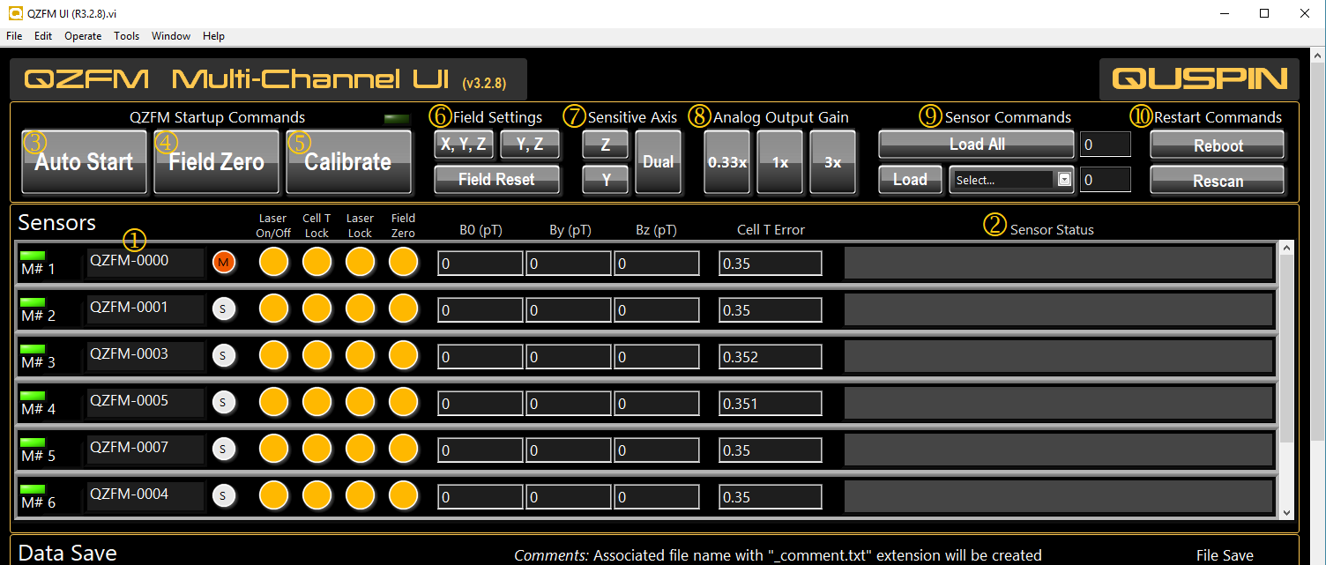](http://quspin.com/wp-content/uploads/2017/07/QZFM_UI_w-sensors-1.png)

Figure 3d: The top portion of the user interface for the QZFM contains all the buttons and indicators for starting, configuring, and monitoring the sensors.

Step 1: Press the [Auto Start] button (3) to bring the sensors online. The startup process takes a few minutes to complete, as indicated by the first three LEDs turning green. The ‘Laser On/Off LED’ will turn green to indicate that the laser is on. Next, the ‘Laser Lock’ LED will turn green when the laser frequency is locked. Finally, the ‘Cell T Lock’ LED will turn green when the vapor cell is at optimal temperature.

Step 2: Once the first three LEDs are green, press the [Field Zero] button (4) once to activate field zeroing. The button will turn amber color while active. When the field values for B0, By, and Bz stop fluctuating (to within a few 100 pT, usually taking between 5-10 seconds), press the [Field Zero] button a second time to stop the process and lock the compensation fields. The fourth LED turns green indicating the compensations fields are applied.

**Note:** It is necessary to repeat the [Field Zero] operation every time the ‘Sensitive Axis’ is switched to a different mode or the background field is expected to have changed significantly (e.g. opening and closing the shields, or moving the sensors).

Step 3: When all 4 LEDs are green, press the [Calibrate] button (5). Wait for calibration values to appear sequentially in each corresponding ‘Sensor Status’ box (this process takes a few seconds per sensor). Calibration values less than 1.5 are considered normal and indicate optimal performance. Calibration values above 1.5 indicate sub-optimal sensor performance, either due to large background field (> 50 nT), or a possible sensor issue.

## At this point the sensors are ready for measurement.

### Additional Controls

**Field Settings** **(6):**  The [X,Y,Z] (default) and the [Y,Z] buttons set the active axes for the [Field Zero] function (4). The [Y,Z] mode is used only when X (B0) compensation is not needed. **Note:** The B0 value is the combined applied field value for X field compensation and internal optimization. The [Field Reset] button will set the applied field values to zero (displayed as -1).

**Sensitive Axis (7):** The [Z], [Y], and [Dual] buttons set the active measurement axis of the sensor. The default mode is single Z-axis and the [Dual] button activates both Y and Z. **Note:** When switching between measurement axes, it is necessary to re-run the [Field Zero] operation followed by [Calibrate].

**Analog Output Gains (8):** These buttons set the voltage gain of the ‘Analog Out’ port. The default [1x] setting corresponds to 2.7 V/nT, the [0.33x] to 0.9 V/nT, and [3x] to 8.1 V/nT.

**Sensor Commands (9):** Refer to the command list for numbers corresponding to specific commands. Type the number in the field to the right of the [Load All] button and press [Load All] to send a command to all connected sensors. Or alternatively, send a command to a specific sensor by selecting it in the drop down menu and typing the command number in that corresponding field and then pressing [Load].

**Restart Commands (10):** The [Reboot] button resets all electronics (similar to power cycling) and reloads the firmware defaults. The [Rescan] button is used to reinitialize the sensor list. **Note:** This button should be used ONLY if sensors are added to or removed from the system. The [Rescan] functions will prompt the user to confirm and reopen the UI, which clears the previous sensor list. Re-opening the UI without a prior list will initiate a scan for connected QZFM sensors, which will take approximately 30-90 seconds.

### Data Save

The QZFM UI provides data saving functionality of the digital output at 200 Hz sampling rate. Simply set the folder path for the data files in the ‘File Path (Folder)’ (1) in Figure 5. To start saving data, press the [File Save] button (3) once to activate data recording (highlighted in red while active). To stop data recording, press the [File Save] button a second time. Any comments typed in the ‘Comments’ field (2) before stopping data recording will be saved along with the data in a separate file with the added file name extension ‘_comment.txt’. Data files with .lvm extensions are saved for each sensor (and the associated comment file) in the selected folder.

[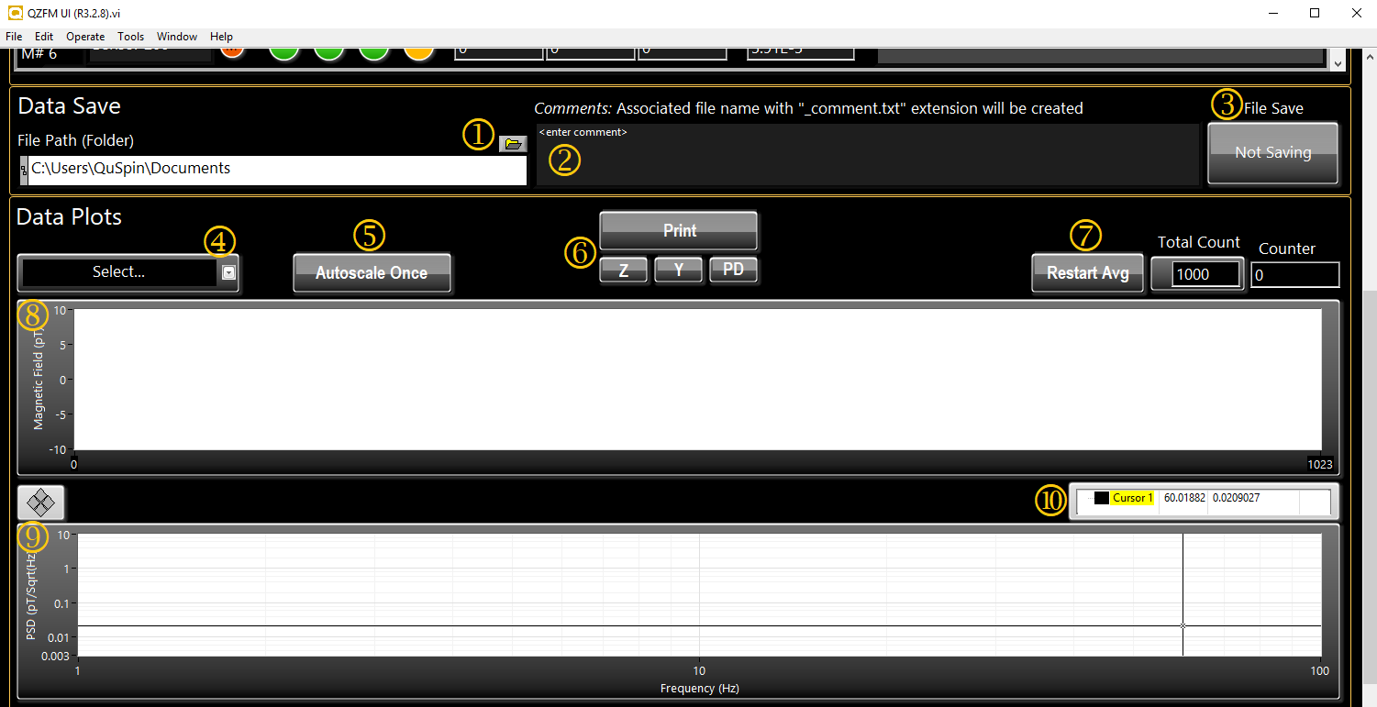](http://quspin.com/wp-content/uploads/2017/07/QZFM_UI_data_save_plots.png)

Figure 3f: The Data Save section provides recording capability of the digital data stream for all connected sensors at 200 samples per second. For each recording session, all notes entered in the comments box will be saved along with the data in a separate text file at the time the recording period is stopped. The data section of the UI allows for the monitoring and plotting of data (time and spectral) for up to two selected sensor.

## Data Plots

The drop-down bar (4) (in Figure 5) allows the user to select a sensor and display its output in the time series chart (8) and frequency spectrum graph (9). Press the [Print] button (6) (highlighted in amber while active) to start displaying the digital output of the selected sensor. **Note:** while the [Print] function is active, other sensor indicators such as the LEDs and Cell T Error will not update. Press [Autoscale Once] (5) to scale the Y-axis of the chart when needed. The [Z], [Y], and [PD] buttons (6) allow for selecting the displayed output of the Z axis, Y axis, or photodiode respectively. The [Restart Avg] button (7) will clear and restart the averaging for the spectral graph.

# Analog MEG

One problem in Digital MEG is that all the sensors are not well synchronized. To synchronize all the sensors, AcqManager also supports professional data acquisition card, such as National Institutional (NI) card. The NI data acquisition cards provide a way to record both EEG and MEG signals.

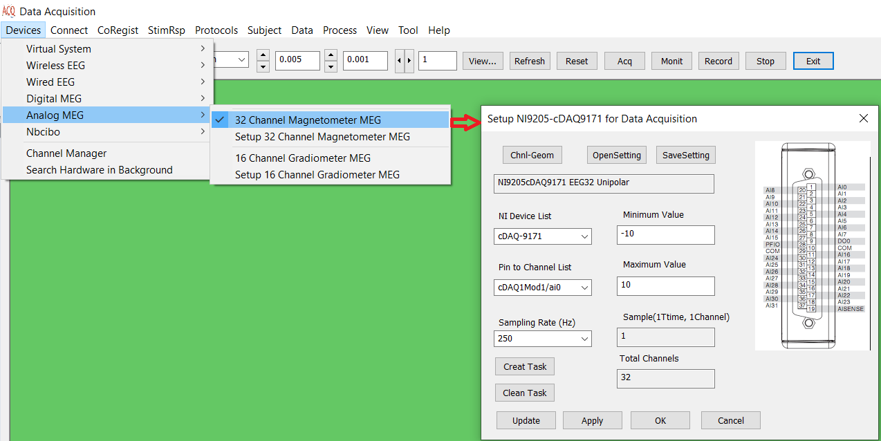Figure 4. GUI for Setup National Instruments DAQmx card and connection pins for recording biomagnetic and bioelectric signals (e.g. MEG, MCG ) .

## 32- Channel Magnetometer MEG:

the system supports 32 channels connected directly to the NI card, which are physically connected to the computer. The magnetic sensors are physically connected to each pin.

## 16-Channel Gradiometer MEG:

The system supports 16 channels connected directly to the NI card, which are physically connected to the computer. If necessary, two orientation of a magnetic sensor can be physically connected to pairs of pins.

# Channel Manager (Setup)

The AcqManager provides templates for each type of studies, or procedure step, so that datasets of each type will display consistently and appropriately. These display settings are stored in the file. When the dataset is first imported, AcqManager uses the default settings in this file to determine the display settings to use.

As shown in Figure 1, AcqManager provides several of display set buttons that allow you to customize displays for any dataset. To switch between display sets, simply click the appropriate combo box or button or edit box. You can change any of the display settings, and your changes can be saved to the file. The next time you load the dataset, the new settings will be restored.

# Search Hardware

This function is designed to search for hardware systems connected to the computer.

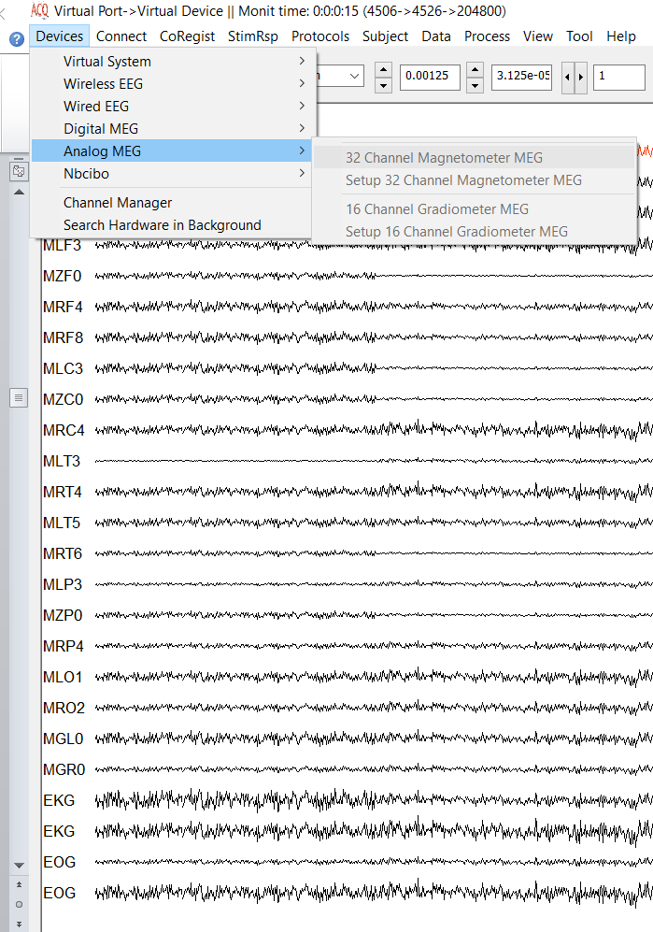

Figure 2. GUI for Selecting Devices.

# Index

E

Electroencephalography (EEG), **5**

F

femtoteslas, 6

M

Magnetic source imaging (MSI), 5

Magnetoencephalography (MEG), 5

Main Frame, 6

P

picoteslas, 6

T

Teslas (T),, 6